# 5Days/4Nights EXPO 2020 DUBAI UAE

(Valid For October 2020 – April 2021)

## DAY 1 ARRIVAL DUBAI (B/L/D)



[**:**](http://phoenixtour.org/wp-content/uploads/2013/12/233.png)

ARR DXB + HD DXB; Photo stop Burj Al Arab,

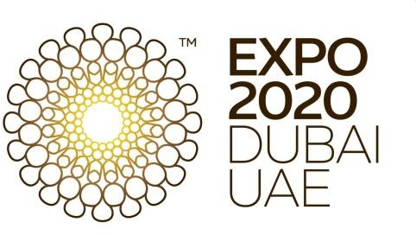Photo stop Atlantis The Palm, Photo stop Dubai Marina, Photo stop Burj Khalifa, Dubai Mall + DESERT SAFARI. **DAY 2 : DUBAI (B)**

FD DXB; VISIT EXPO. **DAY 3 : DUBAI (B)** FD DXB; VISIT EXPO. **DAY 4 : DUBAI (B)** FD DXB; VISIT EXPO.

## DAY 5 : DEPARTURE DUBA[I](http://phoenixtour.org/wp-content/uploads/2013/12/233.png) (B)

Breakfast, transfer to the airport.

## RATE PER PERSON IN USD

**(DBL/TWN)

|  |  |  |  |  |  |  |  |  |
| --- | --- | --- | --- | --- | --- | --- | --- | --- |
| **HOTEL** | **10 + 1**  **20’ COASTER** | **15 + 1**  **35’ BUS** | **15 + 1**  **45’ BUS** | **20 + 1**  **45’ BUS** | **25 + 1**  **45’ BUS** | **30 + 1**  **45’ BUS** | **35 + 1**  **45’ BUS** | **Sgl Supp.** |
| **HOLIDAY INN FESTIVAL CITY/ TRYP BY WYNDHAM/ MILLENNIUM PLACE BARSHA HEIGHTS 4\***  **or similar Category** | **$528** | **$479** | **$499** | **$460** | **$436** | **$421** | **$410** | **$175** |

## RATE INCLUDED:

* Pickup from DUBAI Airport + HD DXB – Half Day Tour including transportation and English/INDO Speaking Guide for 05 hours.
* 3 DAYS Full Day at EXPO with return transfer HOTEL – EXPO – HOTEL including English/INDO Speaking Representative.
* Depart from DUBAI Hotel to DUBAI Airport.
* Evening Desert Safari based on 4WD Dune Bashing, Camel Ride, Tanoura Dance, Belly Dance, Henna Painting, BBQ Dinner (SHARING 6pax/ jeep – WITH DRIVER ONLY).
* ENTRANCE TICKET 3 DAYS EXPO DUBAI.
* 2 small bottle of local Mineral water during excursions.
* 1 BREAKFAST AT RESTAURANT.
* 1 Lunch at restaurant.
* 1 Single room free for 1 Tour Leader from 10 - UP confirmed guests.
* 4 Nights Accommodation in sharing double room on bed and breakfast basis in DUBAI.
* Tourism Dirham Fee
* 5% VAT (value-added-tax)

## RATE EXCLUDED:

* International and domestic flight tickets.
* Travel Insurance & Porter Fee.
* UAE Visa SINGLE ENTRY at USD 76.00 per person.

*subject to immigration approval & nonrefundable*

* Tipping for guide USD 3/person/day and driver USD 2/person/day.
* Personal Expenses.
* Any services not mentioned above.

## IMPORTANT NOTES:

* Unavoidable changes in itinerary might occur due to climate change or governmental policies or exceptional events.
* No reservation has been made in advance, hotels and rates are subject of changes depending on availability request.
* The rates not available during Black-out dates/public holiday.
* Indonesian Speaking Guide confirmation subject to availability upon booking.
* Infant, pregnant women, and guests with serious medical conditions are not allowed to follow Desert Safari except Private Desert Safari and without Dune Bashing.
* Entertainment including Belly Dance and alcohol will NOT AVAILABLE during Holy month of RAMADAN & Islamic Holidays.